I. Introduction

Some people have plenty of spare time, and have no trouble keeping track of their schedule. HelpOUT is NOT an application for these people. For the hustlers, the bustlers, and the go-getters, keeping track of appointments, errands, and other responsibilities can be a challenge. The purpose of our product is to use technology to keep up with the growing demand of the busy folk. HelpOUT integrates multiple internet services to provide a user friendly task scheduler. In addition, HelpOUT saves your favorite places, and helps you plan a trip around town to tackle those pesky errands you have to run. Think of it like your very own personal assistant, made out of 1’s and 0’s!

II. Project Goal and Objectives

Overall goal

Keeping up with all the appointments, errands and even vacations seems to get harder and more time consuming. Browsing through your apps trying to figure out the next step can be stressful and confusing if you track your daily activities on multiple apps. As a result, the need to group all those functionalities into one application seems like the most efficient way to increase the usefulness of these apps.

Specific objectives (problem statement)

The main objective of the helpOUT web app is to provide users the ability to effectively track, manage, and optimize their errands, and the order in which they are carried out. This is accomplished with an intuitive graphical interface that displays equally well in desktop browsers or in mobile device browsers while on the go, leveraging a responsive design, familiar UI elements, and Google Maps functionality to accomplish this.

Significance

HelpOUT converge all your needed functionality to manage daily activities into one application. The most significant feature is the app’s ability to provide you with a specific route to follow in order to complete your task and appointments of a specific day. Also, helpOUT will incorporate the modern flat look that makes the experience even easier for the user to handle.

III. Project Background and Related Work

Cozi Family Organizer

- Keeps track of everyone’s schedule and activities, enables user to create and share shopping lists, and stores recipes.

Mighty Grocery Shopping List

- Allows multiple shopping lists, list specific favorites, stores product catalog, and enables user to send shopping list.

Cozi Family Organizer is more of a public scheduling application while helpOUT is focused on private daily activities.

HelpOUT does not limit the shopping list like Mighty Grocery Shopping List where they have a product catalog of up to 350 products.

IV. Proposed System

1) Requirement Specification

Functional

The core functionality of HelpOUT is the ability to keep track of tasks, and to generate trips based on unfinished tasks. First and foremost, a user will be able to create a profile. Once the user creates a profile, the user will be able to log on to the home page of the website. From the home page, the user will have the following options: Viewing the active tasks in either a list or a timeline, creating new tasks, viewing completed or archived tasks, viewing saved locations, adding new locations, and editing current locations, and creating and editing an errand run.

Let’s talk a little bit more about tasks. The user will input their task by filling out a quick and easy form. Time permitting, we may add a speech recognition API to make creating a new task even easier. Once the task is input, the task will be stored in its own Task object that we will create. The attributes of this object are listed in the features. Once some tasks have been created, there will be page available to view the current tasks.

We want our application to make task creation as easy as possible, which is why the ability to save common locations is a useful requirement that we have included. It is likely, if not inevitable that the user will frequent certain locations much more often than others. The user can go in and add these locations to their personal list. These locations will most likely plug into a Google Places API.

The defining difference between our application and other applications out there is the ability to make trips based on tasks that the user needs to complete. The user will select locations on the map, and the Google Directions API will provide options for optimal routes. Time permitting, we will add functionality that links certain tasks with certain locations.

User Stories

1. As a User, I want to be able to create an Account with the HelpOUT application.
2. As a User, I want to be able to login to the HelpOUT application with my credentials.
3. As a User, I want to be able to log off from the HelpOUT application.
4. As a User, I want to be able to create a new Task.
5. As a User creating a new Task, I want to be able to save the Location as a favorite for future use.
6. As a User, I want to be able to view a list of Locations that I’ve saved as favorites.
7. As a User, I want to be able to edit a saved Location.
8. As a User creating a new Task, I want to be able to select and use a Location from a list of favorites.
9. As a User, I want to be able to view a list of active Tasks I have created.
10. As a User, I want to be able to sort the list of Tasks based on the criteria of due date, priority, or category.
11. As a User, I want to be notified graphically that a date for an active Task is approaching.
12. As a User, I want to be able to opt-in for and receive email notifications when a date for an active Task is approaching.
13. As a User, I want to be notified graphically that a date for an active Task has past.
14. As a User, I want to be able to opt-in for and receive email notifications when a date for an active Task has past.
15. As a User, I want to be able to view a timeline of Tasks I have created.
16. As a User, I want to be able to delete an active Task.
17. As a User, I want to be able to select a Task and designate it as complete.
18. As a User, I want to be able to view a list of completed Tasks.
19. As a User, I want to be able to create a Trip consisting of one or more Tasks to generate an optimal route with directions..
20. As a User, I want to be able view active Trips I have created.
21. As a User, I want to be able to edit an active Trip.
22. As a User, I want to be able to select a Trip and designate it as complete.
23. As a User, I want to be able to view completed Trips.

Non-functional

Since we will be advertising HelpOUT to a large number of users, usability is a huge factor in non-functional requirements. Usability will be most present when users find our web app helpful in everyday tasks. Some of the features that are connected to usability are notifying the user of their due dates and upcoming appointment. These kinds of activities are the ones we should focus on if we plan to make a usable app.

In addition, performance is an important requirement that will enable users to reach the desired pages and parts of the web app easily without wasting a lot of time waiting for loading. Also, apart from the user's perspective, we will make sure that the code is easily maintainable and easy to understand. In other words, the source code shall be well documented and conforms to best programing practices.

Business Process/Workflow analysis

On the first page of the application, a user will be able to login if they already have an account or register for a new account. New user will be directed to add new tasks on the task list. When a task has been added the user can view the either as a list or on task timeline. Adding a task will require name, location, due dates, priority, type or category of task, coments(shopping list), and frequency of the task.

Once a user has added a task, the task will be visible on task list as incomplete task. As soon as the task is completed the user has an option to mark the task as completed. When the task is marked completed, the system will added to task archive. The user can also delete the task from task list. Once the task is deleted, it will not be visible again.

Locations that have been added to the list will be saved for future reference. If a user wants to use old locations to schedule new tasks, the application will enable them to do so. Saved locations could also be edited by the user.

When a user has inputed locations, the application will show more information of the location including closing times, ratings and driving directions. If the locations are more than one, the application will generate possible driving routes. The possible routes will have total amount of time it will take for one to drive around putting into consideration the closing time of user chosen locations.

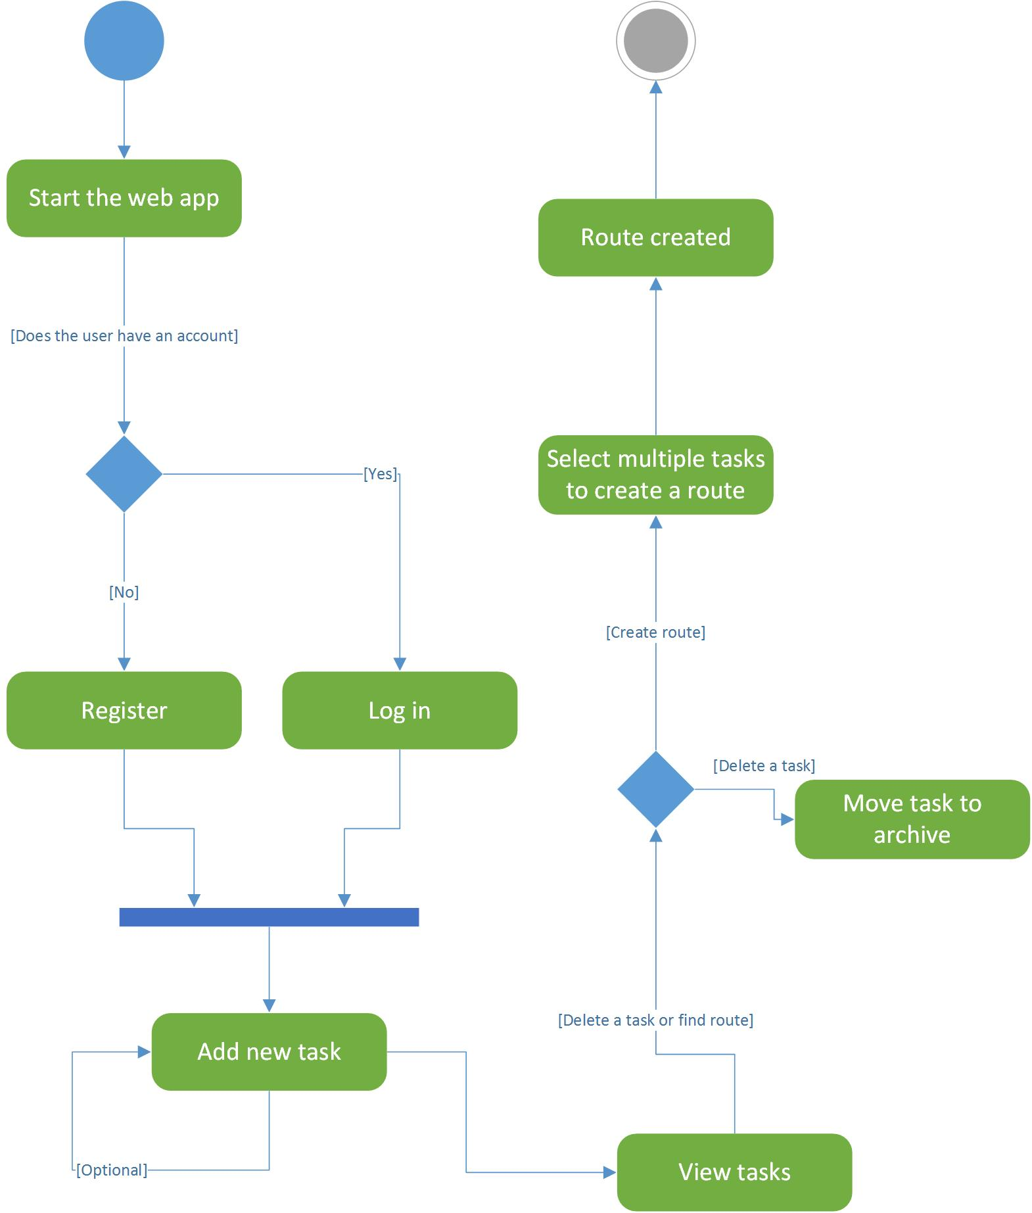

2) Framework Specification: Build an overall system model

Assumptions and Principles

For the front end of HelpOUT web application, we will be using Angular.js and CSS. For the back end, we will be using ASP.net framework. HelpOUT is a web application for desktops and laptops. However, using Bootstrap, we will make sure the application is mobile friendly. The local database will be made using SQL. We will also be using Google Maps API and Google Places API to obtain information about directions and locations. In addition, content on the application can be shared using Facebook or Twitter.

Design Pattern

MVVM (model view viewmodel) for front end design pattern and back end will be MVC (model view controller) and REST for connecting with API services as well as retrieving data from the application server.

System Architecture Diagram

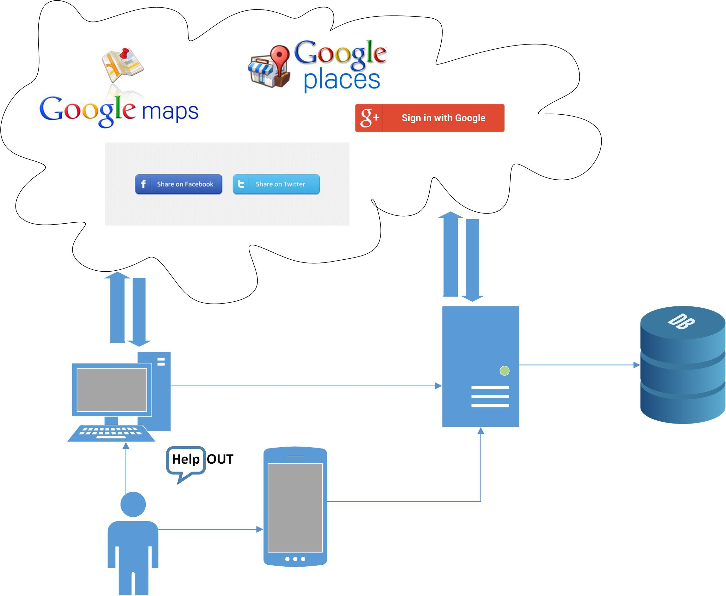

3) System Specification: Identify Primary Services

Existing Services:

1- Google Directions API:

This library will be used mainly to provide the user with the direction from one location to another showing the map and the steps to reach the desired location.

[https://developers.google.com/maps/documentation/directions/](https://developers.google.com/maps/documentation/directions/intro)

2- Google Places API:

Google places is helpful for making sure that the locations the user wishes to visit are not closed at the time of creating the route.

<https://developers.google.com/places/>

3-Google Distance Matrix API:

This API is perfect for choosing multiple locations and trying to find the best route that goes through all of them keeping in mind the closing times of different locations.

<https://developers.google.com/maps/documentation/distance-matrix/intro>

4- Twitter API:

Twitter will help share user daily stories and maybe send out alerts for shopping sales.

<https://dev.twitter.com/web/sign-in>

5- Facebook:

This application API will help the user share their locations, ideas and activities.

<https://developers.facebook.com/products/login>

New Services to be built:

1-Local SQL Database

In the database, we will store the user’s custom locations and other system preferences.

V. Project Plan (using Kanban Tool) – include screenshots to your report

1) Schedule for the four different increments (for each increment, do the following tasks)

Stories (features): Scenario & Use case specification template

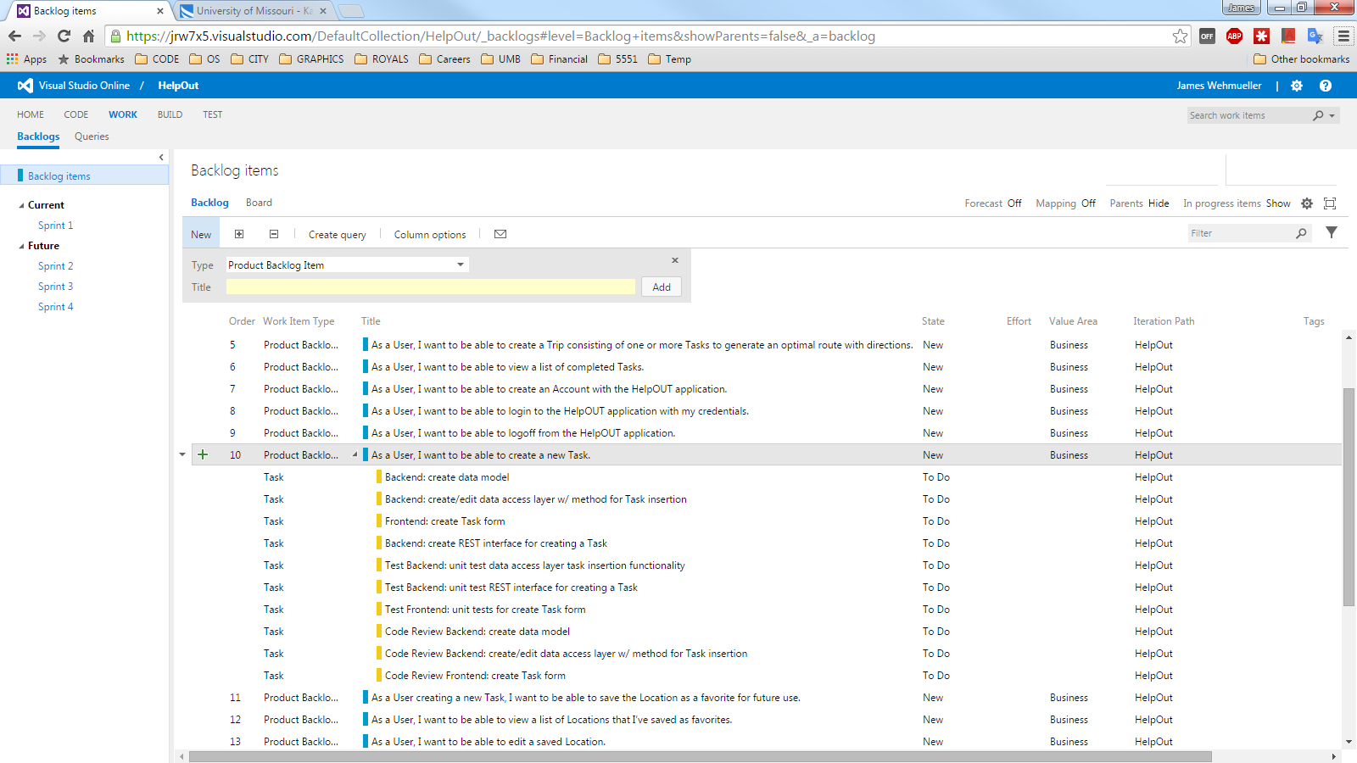

2) Project Timelines, Members, Task Responsibility

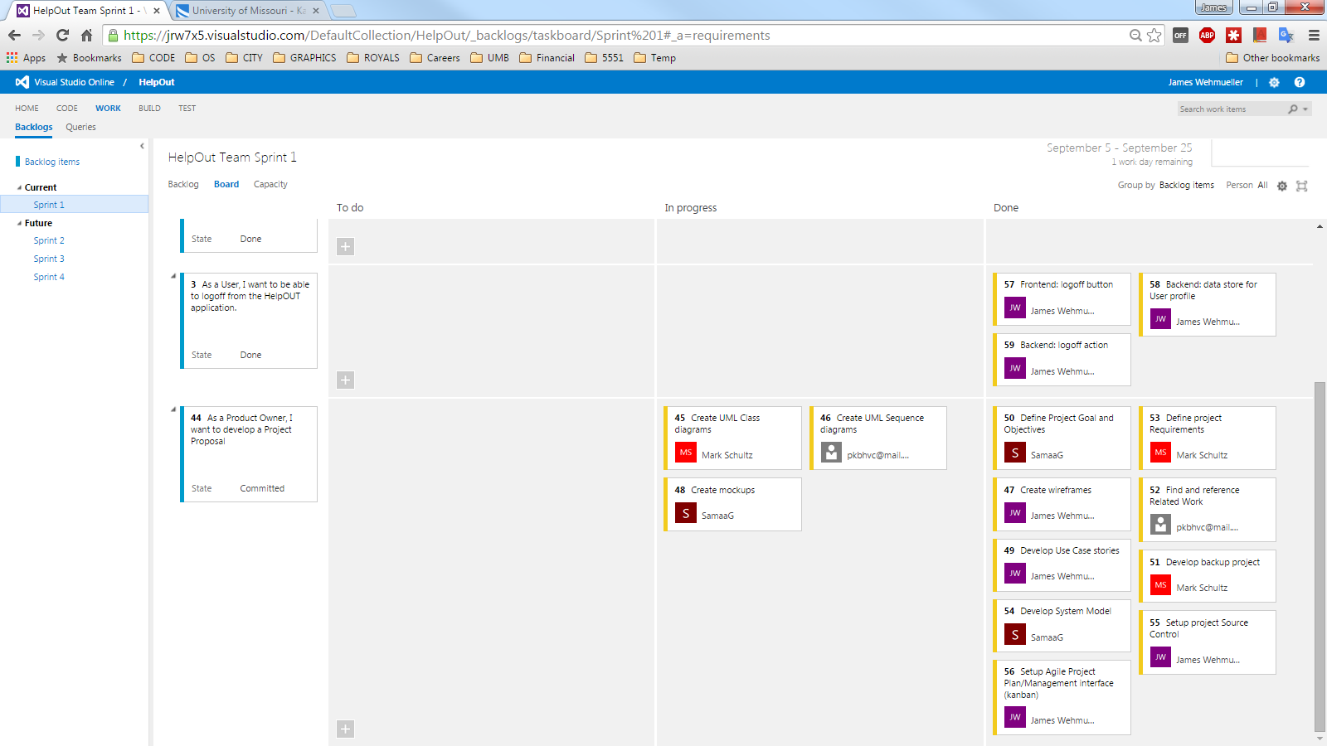

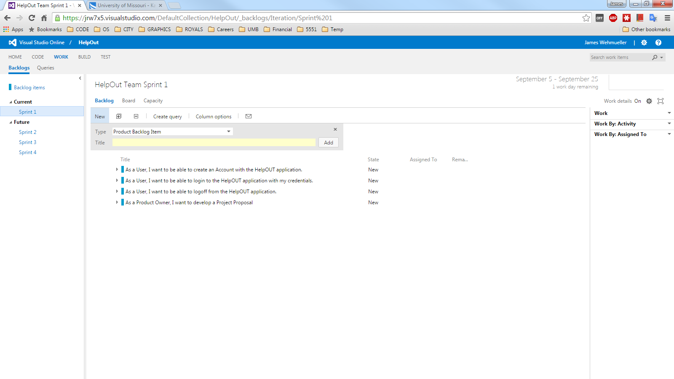

VI. First Increment Report

1) For each service, specify the followings:

Class diagram

Sequence diagram

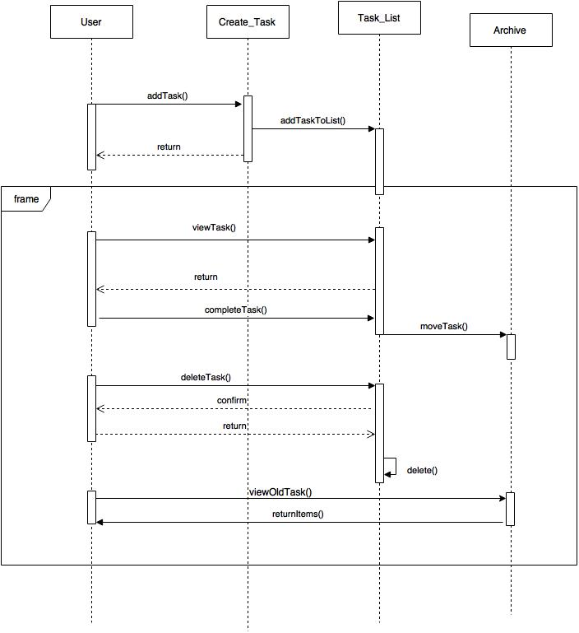

2) Design of Mobile Client (using Visio, adobe Brackets, JSFiddle)

WireFrames:

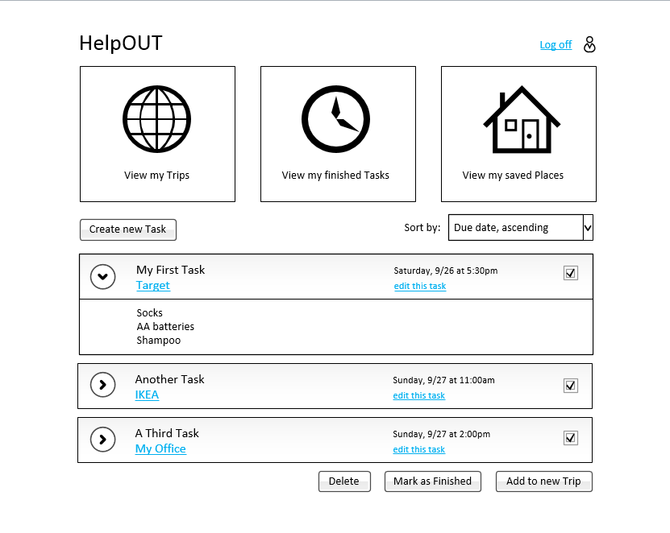

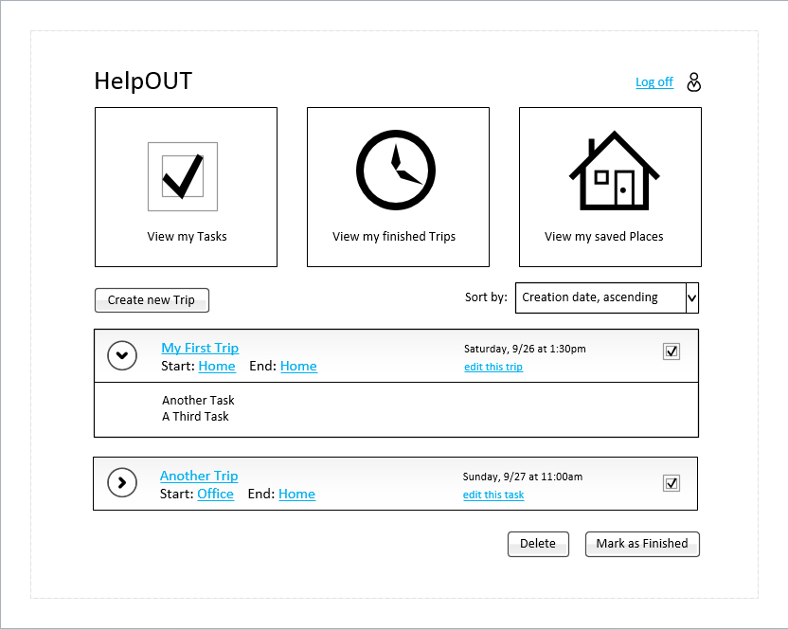

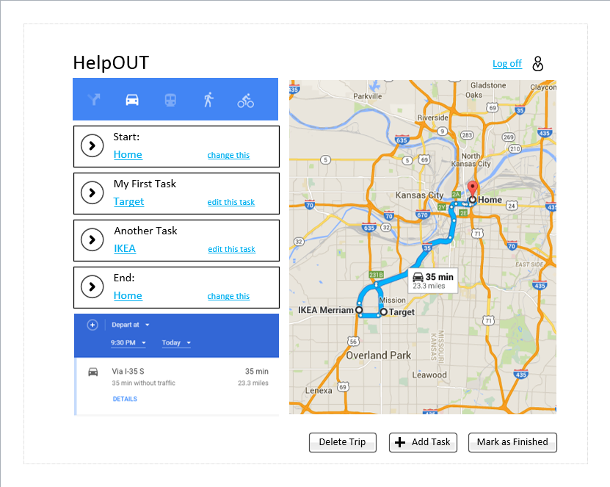

Mockups:

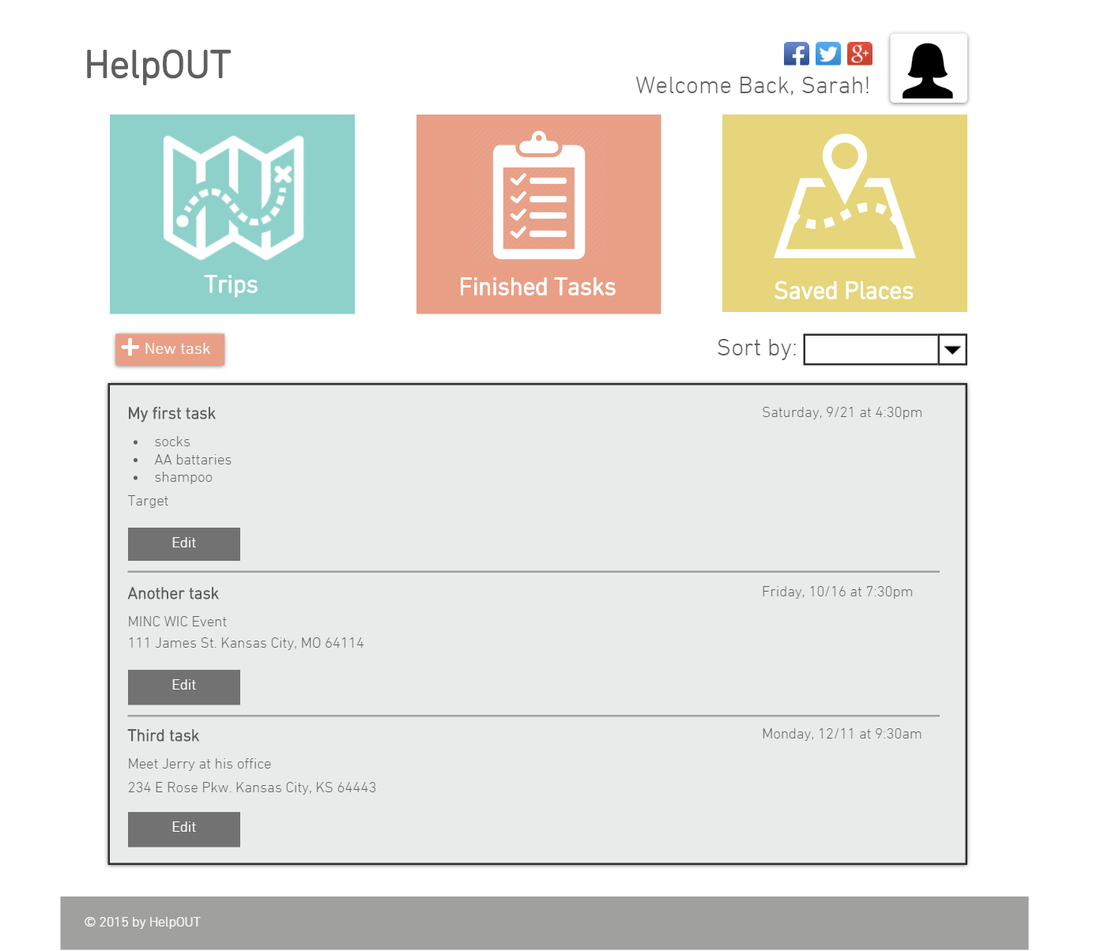

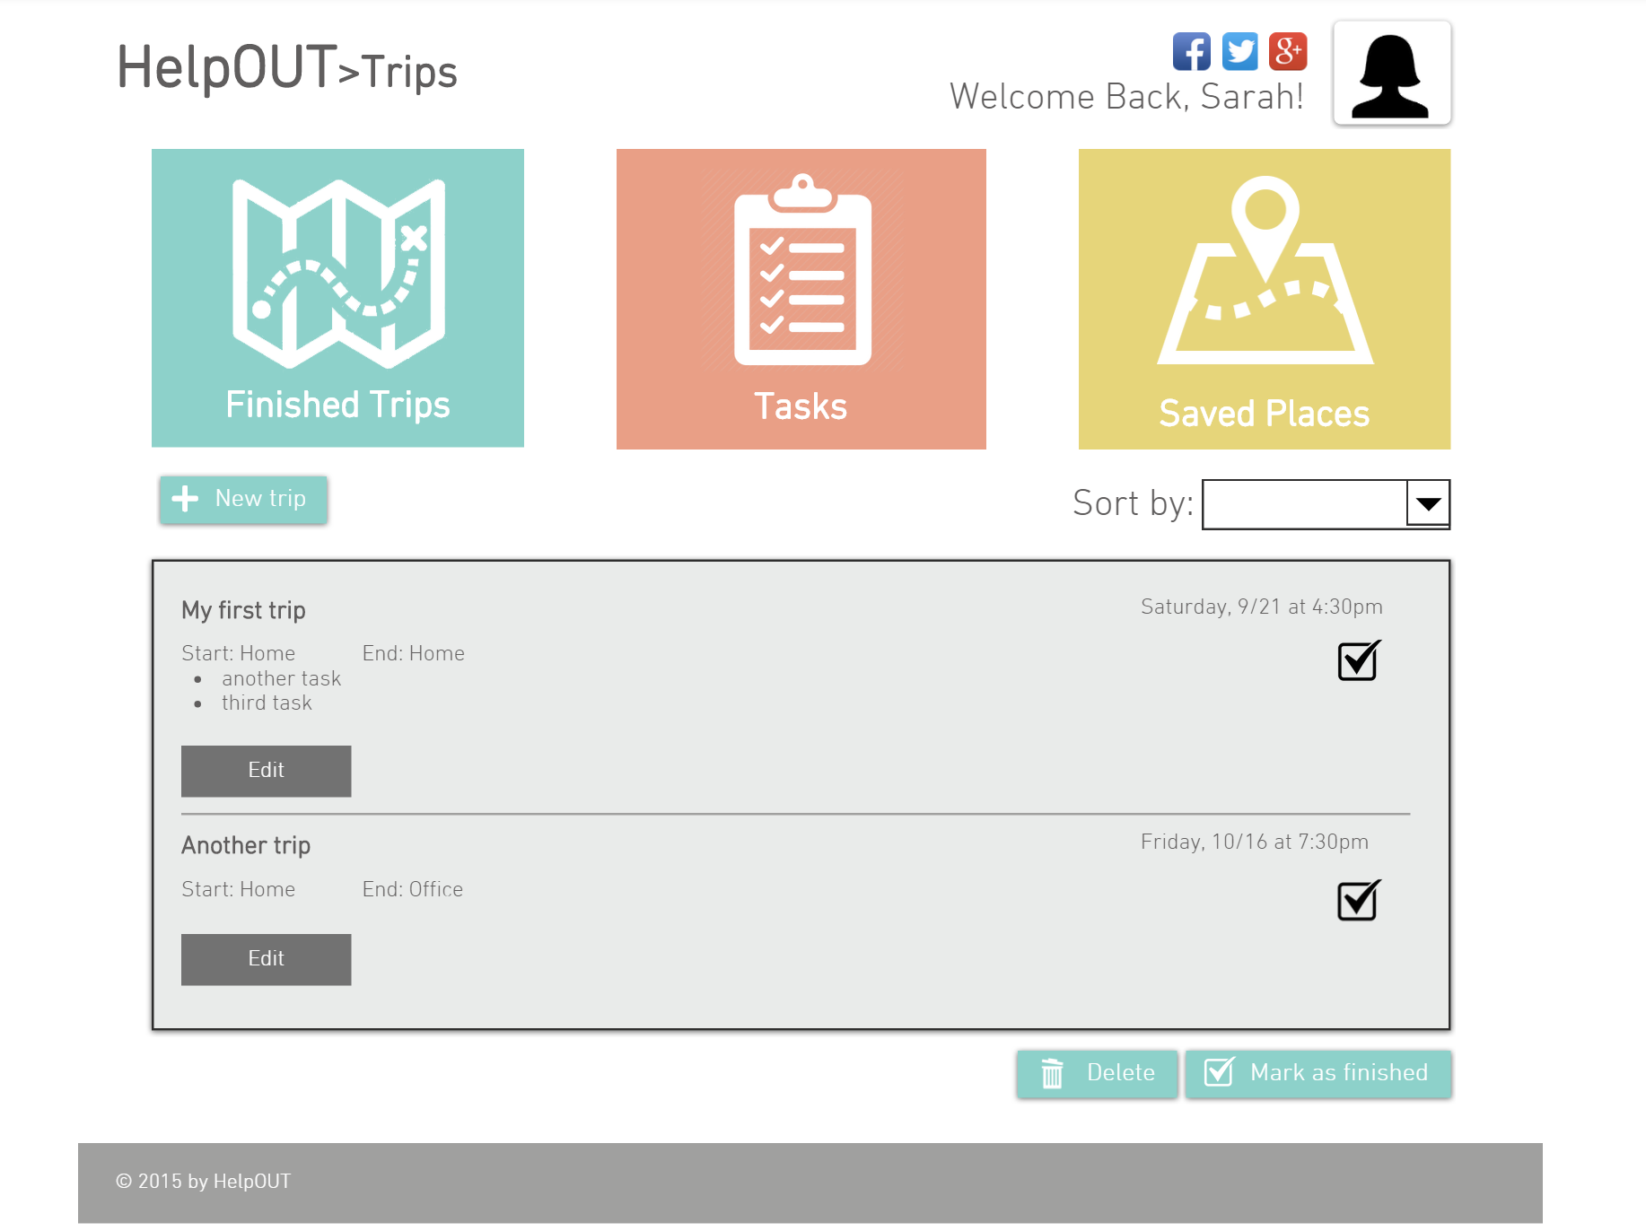

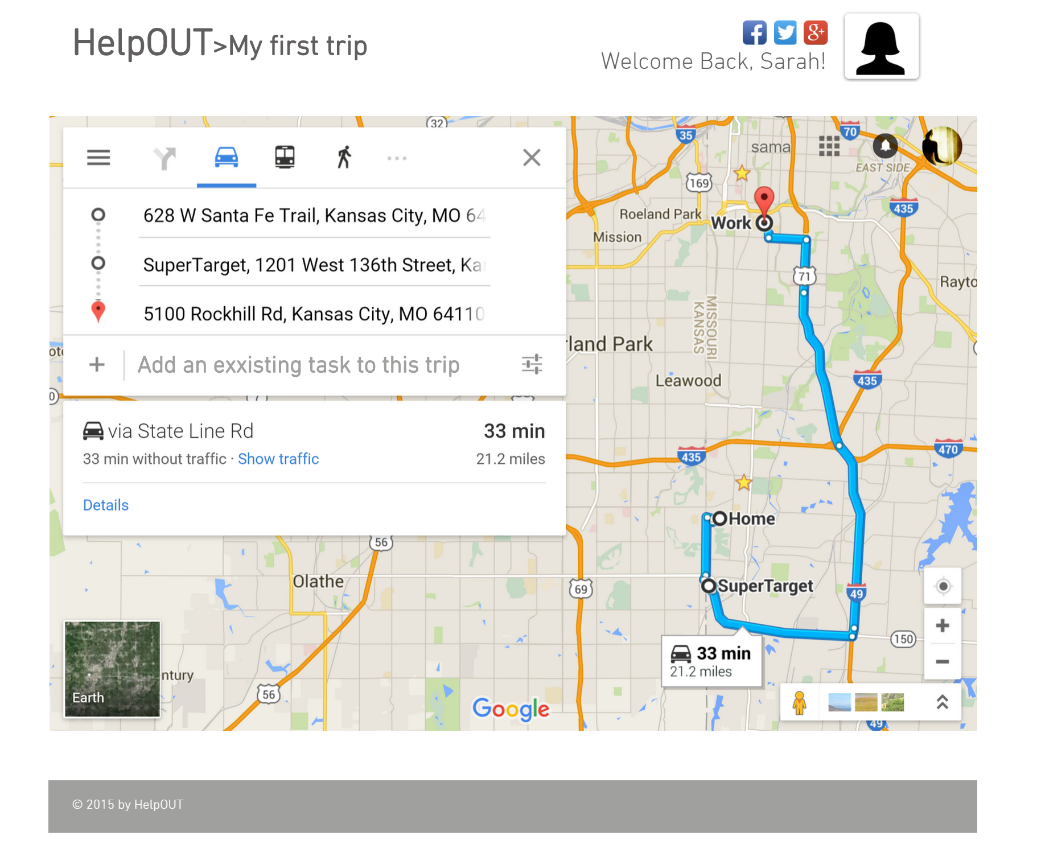

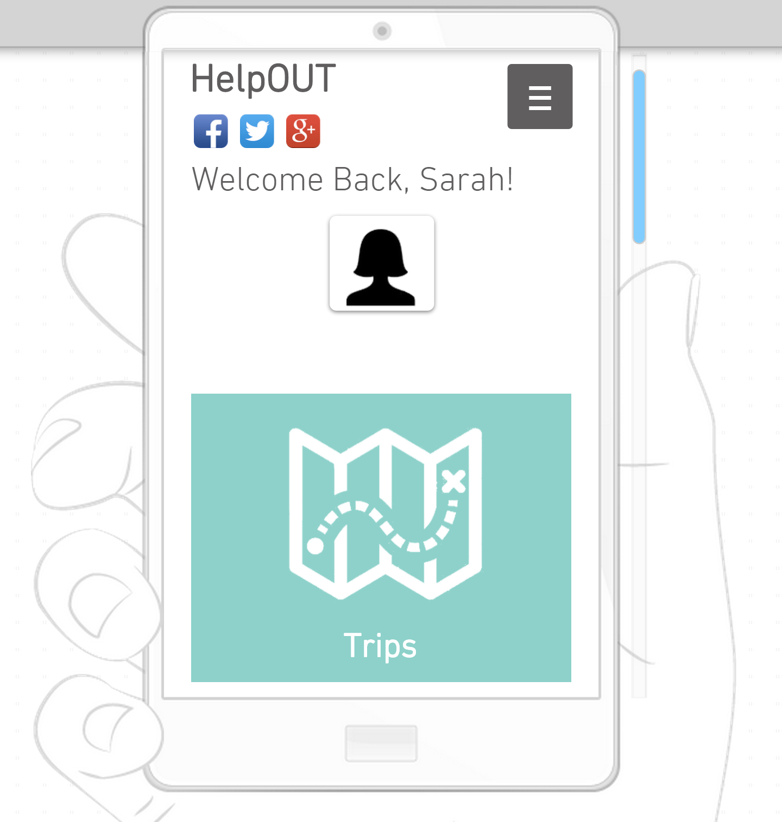

VII. Deployment

We will be using Microsoft Azure to deploy our webapp.